PENETRATION TESTING REPORT
FOOTPRINTING & NETWORK SCANNING PHASES
W2-PM-FINAL | CYBERSECURITY | NETWORKWALKS
Pentester Name (Cybersecurity Professional) | Maida Shafaq
Program/Batch | B083D - Networkwalks
Date | 11 September 2026
Modules completed | W2-PM1 (Multiple Kali Tools)  W2-PM5 (Zenmap Scanning)
Client/Target | 1. Networkwalks (secured written permission already)  2. My own local LAN network
Permission secured from client? | Yes (networkwalks.com and own LAN).
Phases covered | Phase 1: Reconnaissance & Footprinting  Phase 2: Scanning & Network Discovery  Phase 3-5: In Progress

1. Liability Disclaimer
I have performed these activities only on the systems and devices where I had secured written permission, or the devices/systems that I own myself. All these materials are for education and research purposes only. Do not use anything from here to break the law. The instructor, the authors and Networkwalks are not responsible for what I do with this knowledge. Every action I take is my own responsibility. Misuse can lead to criminal charges, heavy fines, loss of job and a permanent record. In most countries unauthorised access is a crime even when nothing is damaged.

2. Introduction
This report covers two modules completed during Week 2 of my Cybersecurity & Ethical Hacking internship at Networkwalks: footprinting the networkwalks.com domain using multiple Kali Linux tools (W2-PM1), and scanning my own local network with Zenmap (W2-PM5). Together, these exercises demonstrate two important stages of a penetration-testing methodology: information gathering and network discovery.
All footprinting activities were performed using Kali Linux, while the network scanning activity was performed using Zenmap on Windows. For each activity, I documented the command or tool used, the observed result, supporting screenshots, and the security relevance of the information collected.

3. Tools Used
The table below lists each tool used in this report and its purpose.
Tool | Purpose
Kali Linux & Windows | Operating systems used for reconnaissance and scanning activities
WHOIS | Find domain registration details (owner, dates, name servers).
whatweb | Fingerprint web technologies (server, CMS, plugins, IP).
nslookup | Resolve the domain name to its IP address using DNS.
curl -I | Read the HTTP response headers of the website.
wafw00f | Detect whether a Web Application Firewall protects the site.
dnsrecon | Enumerate all DNS records (NS, MX, SPF, TXT, SRV).
Zenmap (Nmap GUI) | Scan the local subnet to find live hosts, IPs and MAC addresses.
Windows CMD (ipconfig) | Local IP and subnet identification.

4. Activities Performed

4.1 Footprinting & Reconnaissance (W2-PM1)
I performed reconnaissance against the networkwalks.com domain using six Kali Linux tools: WHOIS, WhatWeb, Nslookup, Curl, Wafw00f and DNSRecon. Each tool was used to collect a different type of information about the target.
First, I used WHOIS to obtain publicly available domain registration information and identify the domain's name servers, registrar and key dates. This provided information about the domain's registration and hosting infrastructure.
I then used WhatWeb to identify technologies used by the website. The results identified WordPress 7.1, Bootstrap 7.1, an Apache server, and the site's IP address (192.232.216.135), along with other information exposed by the website.
Using Nslookup, I resolved the domain name to its IP address. The result identified 192.232.216.135.
I used Curl with the -I option to inspect the HTTP response headers. The response returned HTTP/2 200 and exposed the WordPress REST API endpoint (/wp-json/), along with permissions-policy and other headers.
Next, I used Wafw00f to determine whether a Web Application Firewall was protecting the website. The result identified ModSecurity (SpiderLabs).
Finally, I used dnsrecon to enumerate DNS records. The results identified the SOA and NS records (ns6135/ns6136.hostgator.com), an MX record (mail.networkwalks.com), TXT records (an SPF policy and a Google site-verification token), and 8 SRV records relating to autodiscover/cpanelemaildiscovery services. No DNSSEC answer was returned for the domain.

4.2 Network Scanning with Zenmap (W2-PM5)
For the third activity, I used Zenmap to perform network discovery on my own local network. The task required me to identify my local IP address and subnet, discover live hosts, identify their IP and MAC addresses, and generate a network topology.
I first used the Windows ipconfig command to identify my local IP address and LAN subnet mask (255.255.255.0). I then entered my subnet, 192.168.1.0/24, into Zenmap's Target field and selected the Ping scan profile to identify active hosts.
The scan (nmap -sn 192.168.1.0/24) completed in 6.28 seconds and identified 14 live hosts out of the 256 addresses in the subnet:
- 192.168.1.1
- 192.168.1.8
- 192.168.1.91
- 192.168.1.119
- 192.168.1.126
- 192.168.1.137 (my own PC)
- 192.168.1.141
- 192.168.1.142
- 192.168.1.146
- 192.168.1.150
- 192.168.1.158
- 192.168.1.165
- 192.168.1.170
- 192.168.1.174
After completing the scan, I opened the Topology section in Zenmap, enabled the legend, reviewed it, and saved the network topology as a PDF file on my desktop as required by the task. I also answered the accompanying questions on the Networkwalks Zenmap practice lab page using these same results.

5. Risk Analysis / Impact
Based on the information collected during the footprinting, and network scanning activities, I identified the following potential risks.
# | Risk / Finding | Evidence / Observation | Potential Impact | Risk Level
1 | Web technology information exposed | WhatWeb identified WordPress 7.1 and server details on networkwalks.com | Attackers may match exposed software/versions against known vulnerabilities | Medium
2 | Server IP address identifiable | Nslookup resolved networkwalks.com to 192.232.216.135 | Reveals network location of the web service, enabling direct scanning | Low
3 | HTTP technical information exposed | Curl -I returned HTTP headers and exposed the /wp-json/ REST API endpoint | May assist technology fingerprinting and further enumeration | Low
4 | WAF technology identifiable | Wafw00f identified ModSecurity (SpiderLabs) protecting networkwalks.com | Reveals the site's security architecture, shaping how an attacker would evade it | Low
5 | DNS infrastructure information exposed | DNSRecon enumerated NS, MX, SPF/TXT and 8 SRV (autodiscover) records | DNS information can help build a broader infrastructure and email profile | Medium
6 | Multiple live hosts visible on local network | Zenmap ping scan of 192.168.1.0/24 identified 14 live hosts with distinct IP and MAC addresses | Unknown or unauthorized devices may potentially be present on the network | Medium

The risks above are observations from the footprinting, and scanning exercises, not confirmed vulnerabilities. The practical exercises primarily involved information gathering and host discovery. No exploitation or vulnerability validation was performed as part of these two modules. Therefore, the presence of information such as a software version, IP address, subdomain, or DNS record does not by itself mean that any system is vulnerable. Further authorized security testing would be required to confirm any actual vulnerability.

6. Recommendations
Based on the observations from these activities, I recommend the following security improvements:
- Review publicly exposed technology information - Organizations should regularly review what information about their web technologies, CMS and plugins is publicly visible.
- Keep software updated - CMS platforms, plugins and other web technologies should be regularly updated and reviewed against current security advisories.
- Review HTTP headers - HTTP response headers should be reviewed to determine whether unnecessary technical information is being exposed.
- Review DNS records regularly - DNS records should be checked periodically to ensure that only required information and services are publicly exposed.
- Properly configure and monitor the WAF - Keep the WAF (ModSecurity) enabled and tuned, since it already blocks naive attacks.
- Investigate unknown devices - Any unexpected device discovered during network scanning should be investigated and verified.
- Maintain network documentation - Network topology and device information should be documented and updated regularly.
- Perform security testing with authorization - Reconnaissance and scanning should only be performed against systems and networks where appropriate authorization has been provided.

7. Conclusion
During Week 2 of my Cybersecurity & Ethical Hacking internship, I completed practical activities covering footprinting, and network scanning.
In the footprinting activity (W2-PM1), I used six Kali Linux tools to collect information about the target domain networkwalks.com. I learned how WHOIS can provide domain information, WhatWeb can identify web technologies, Nslookup can resolve domain names, Curl can inspect HTTP headers, Wafw00f can identify a WAF, and DNSRecon can provide additional DNS information.
In the network scanning activity (W2-PM5), I used Zenmap to identify my local network configuration and discover active hosts. I also collected IP and MAC address information and created a network topology diagram.
The exercises showed me that information gathering is an important part of cybersecurity. Even before attempting to exploit a system, a security professional can learn a significant amount about an environment by carefully analyzing publicly available information and network responses.
I also learned that technical findings should be documented clearly. A good cybersecurity report should explain what was performed, what was discovered, what the observation means, what risk it may create, and what can be done to reduce that risk.
Finally, I learned that reconnaissance and scanning must always be performed within an authorized scope. These activities were completed as part of the assigned educational cybersecurity lab, with written permission secured for networkwalks.com and my own LAN.
8. Evidences Collected
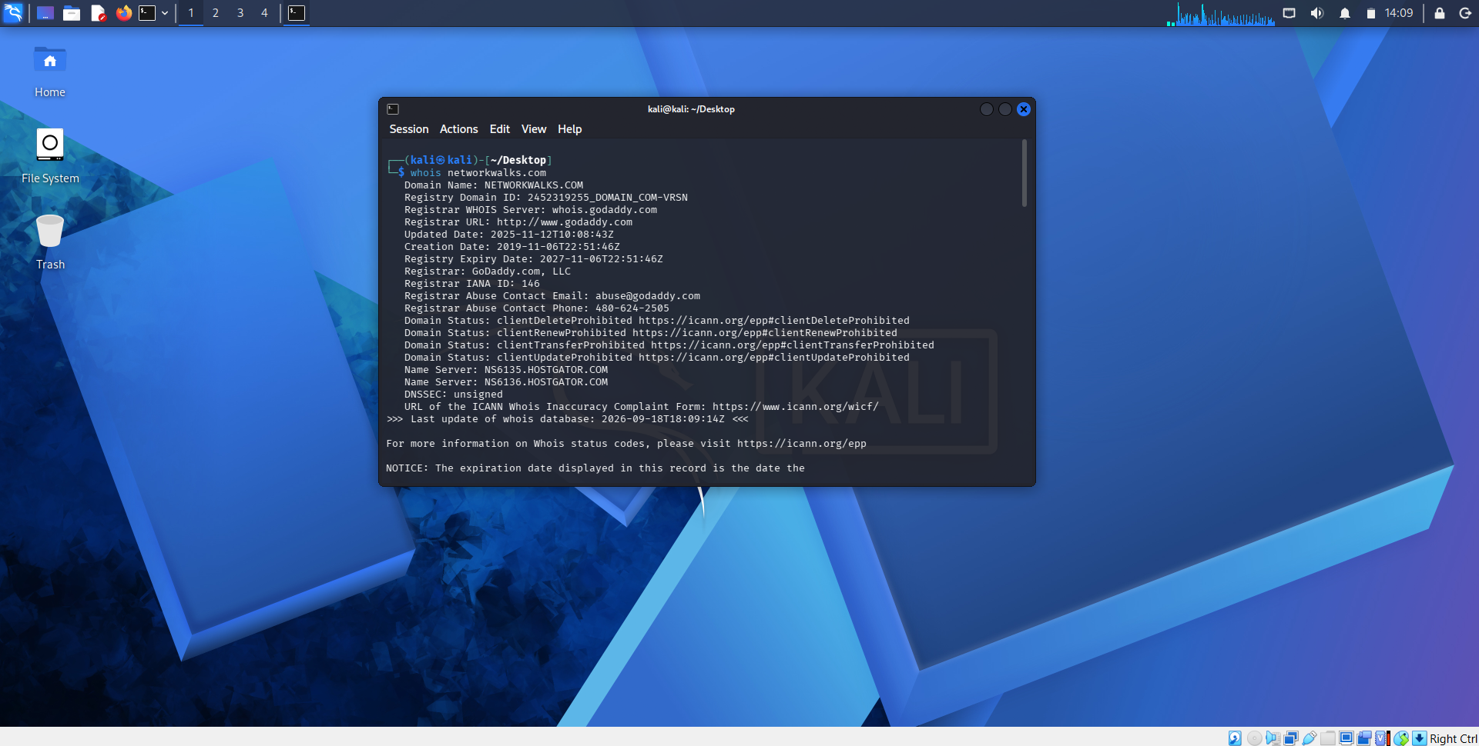

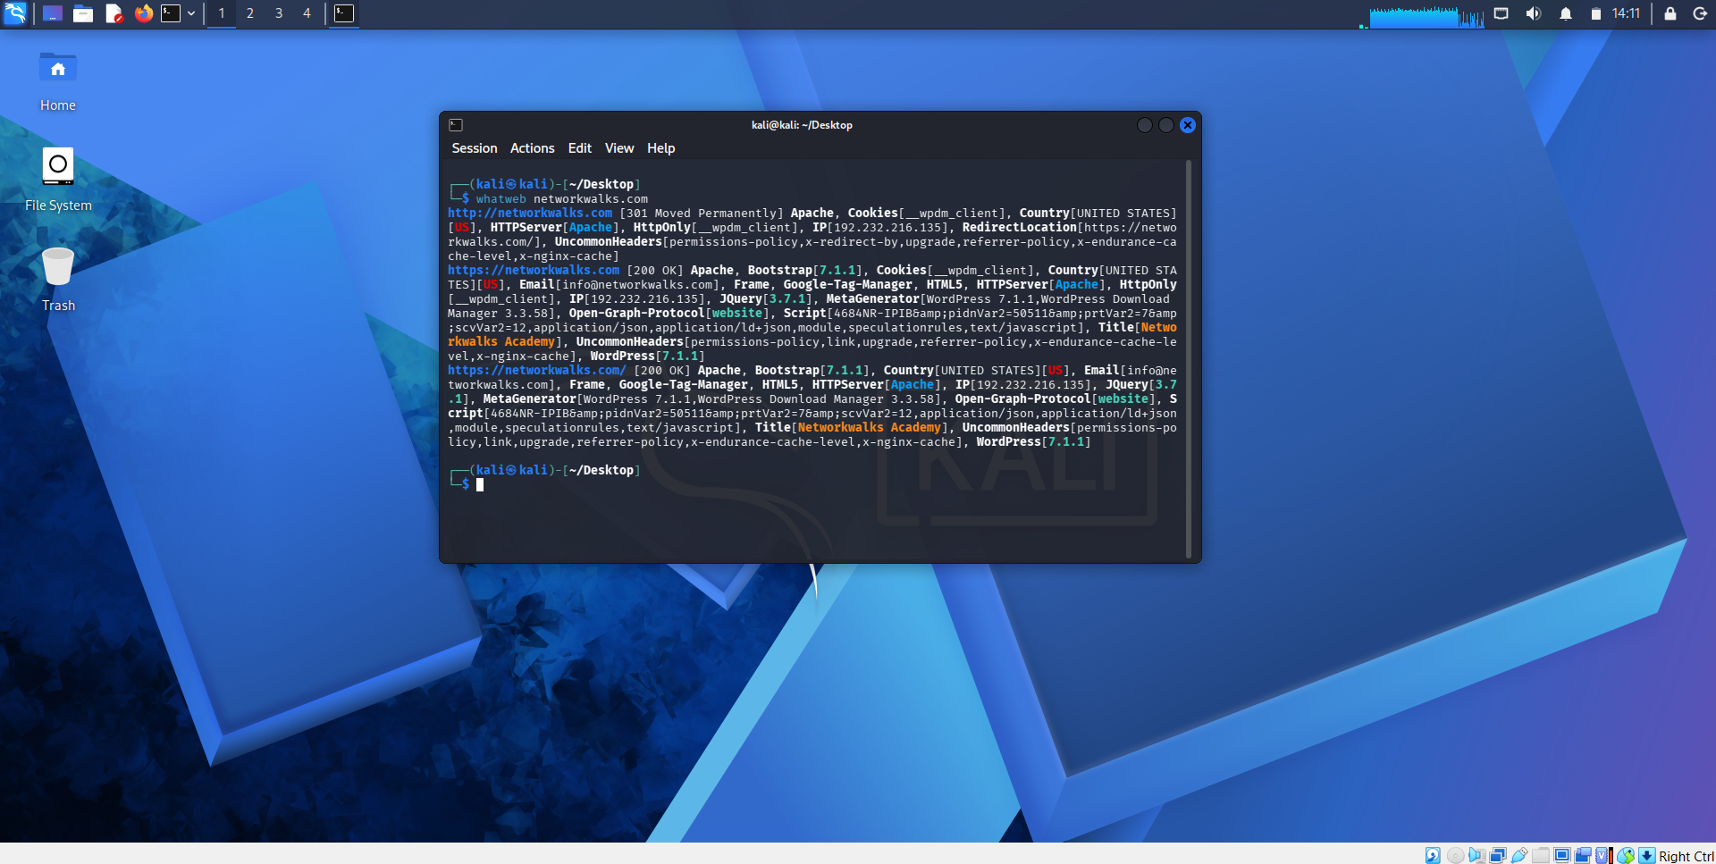

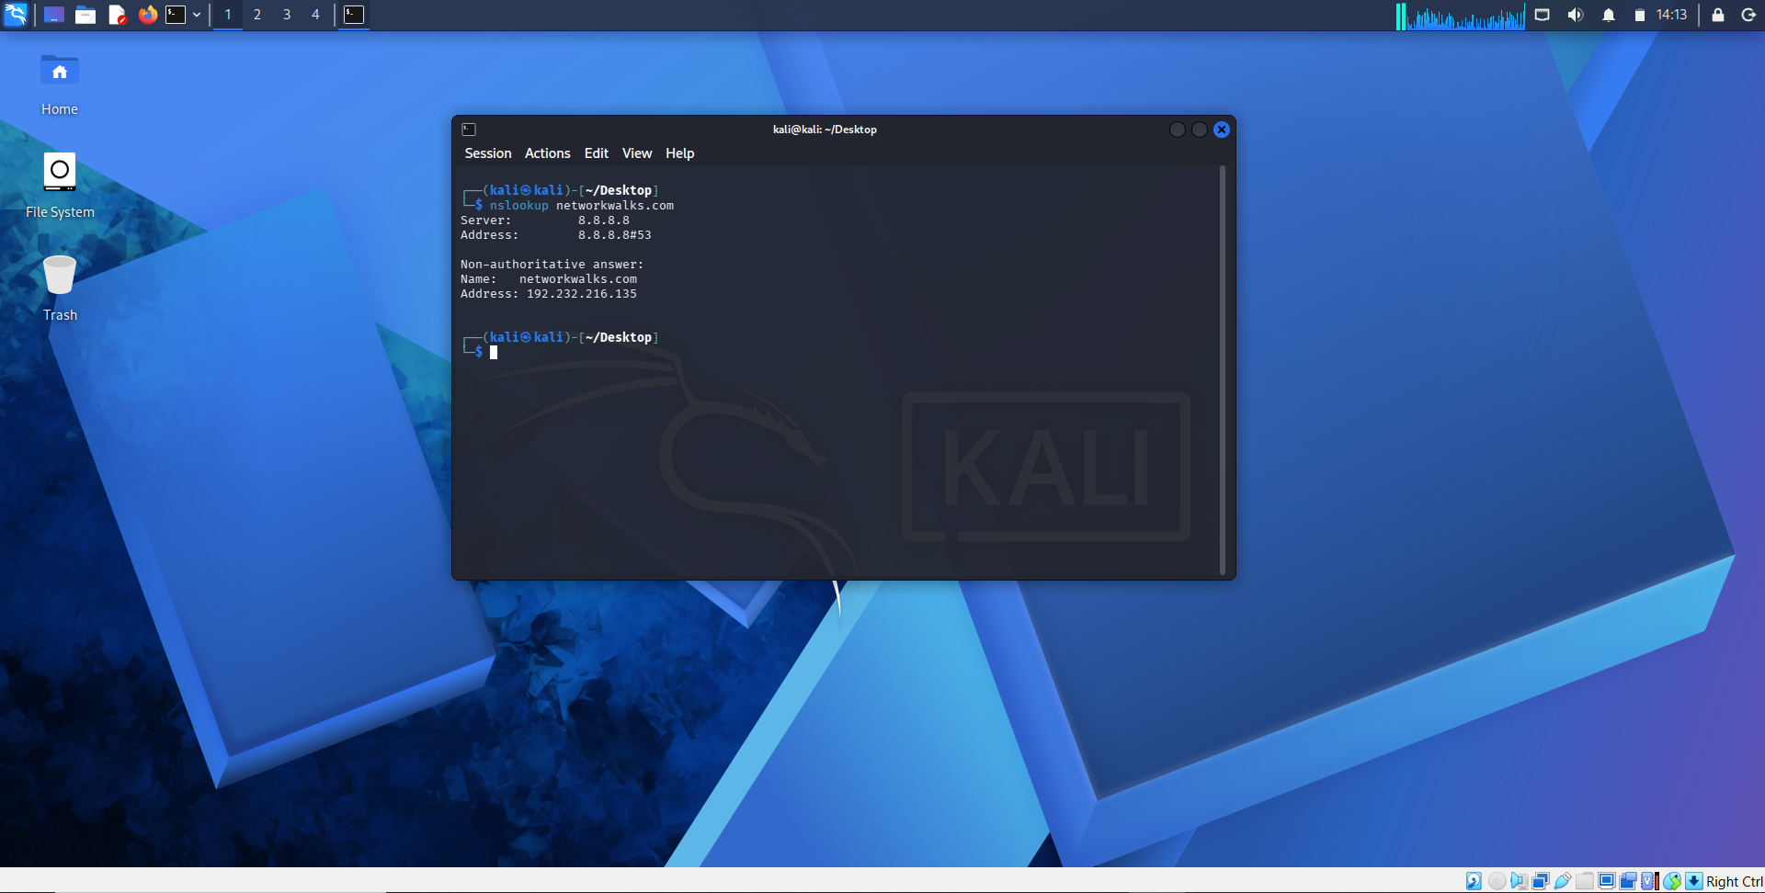

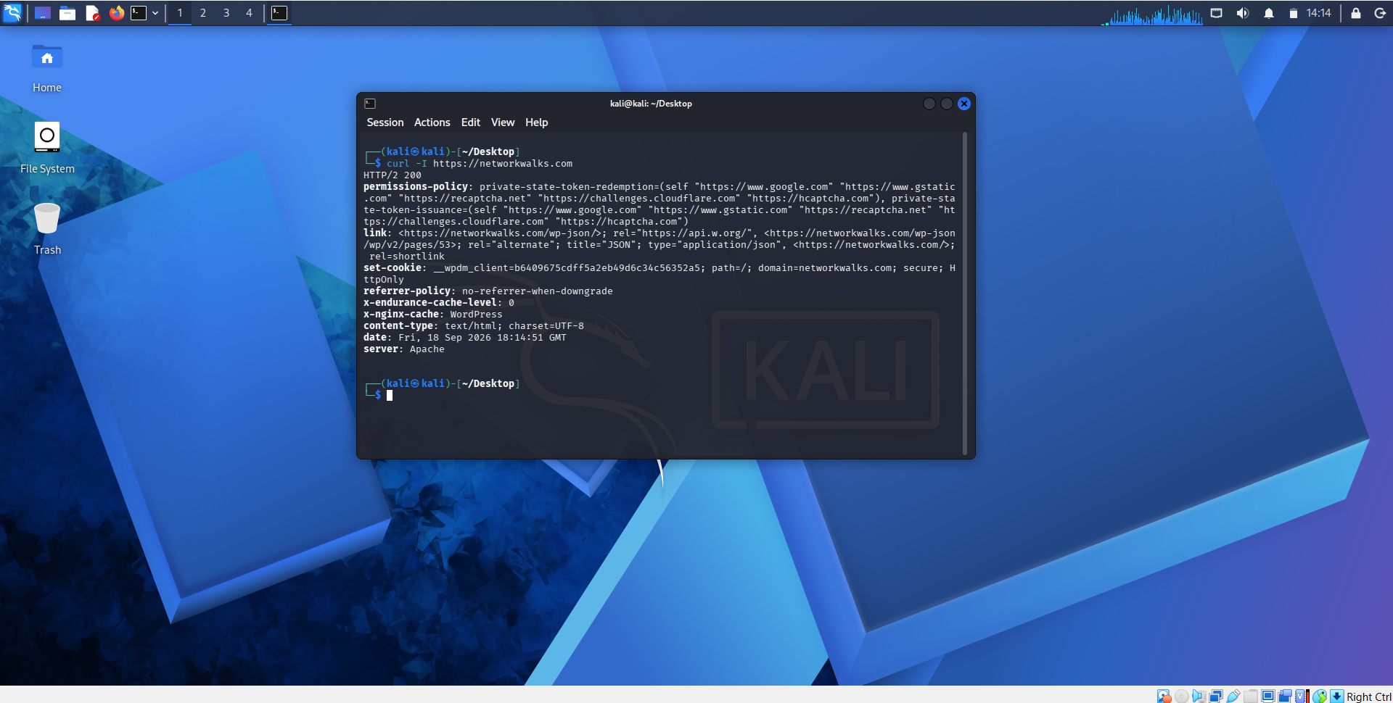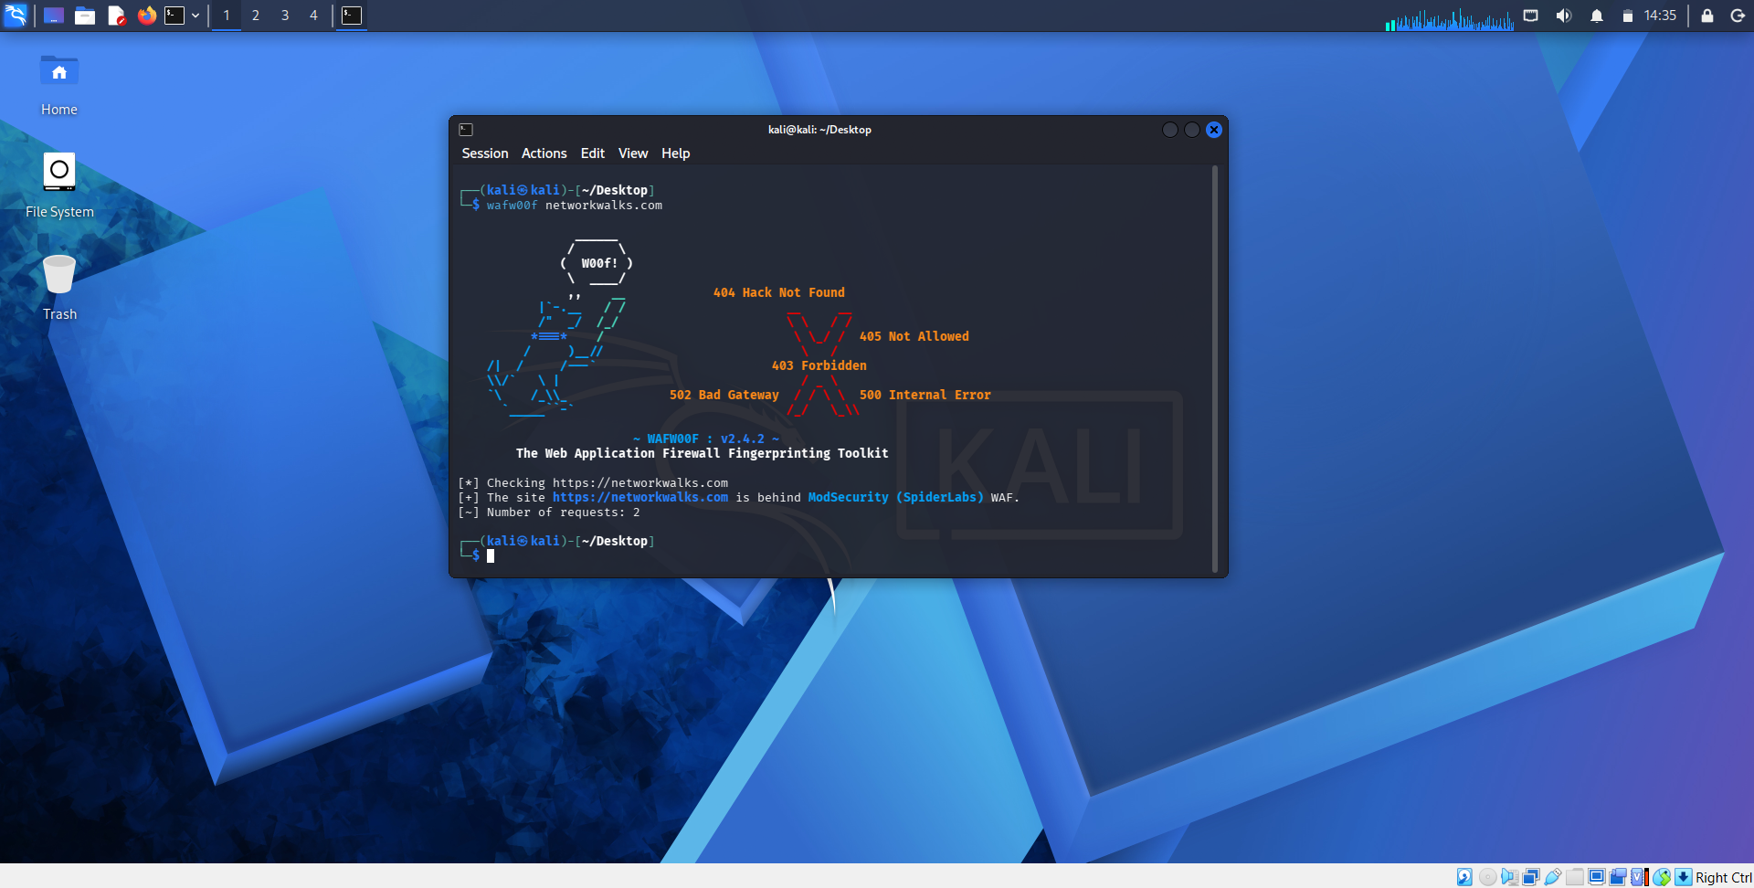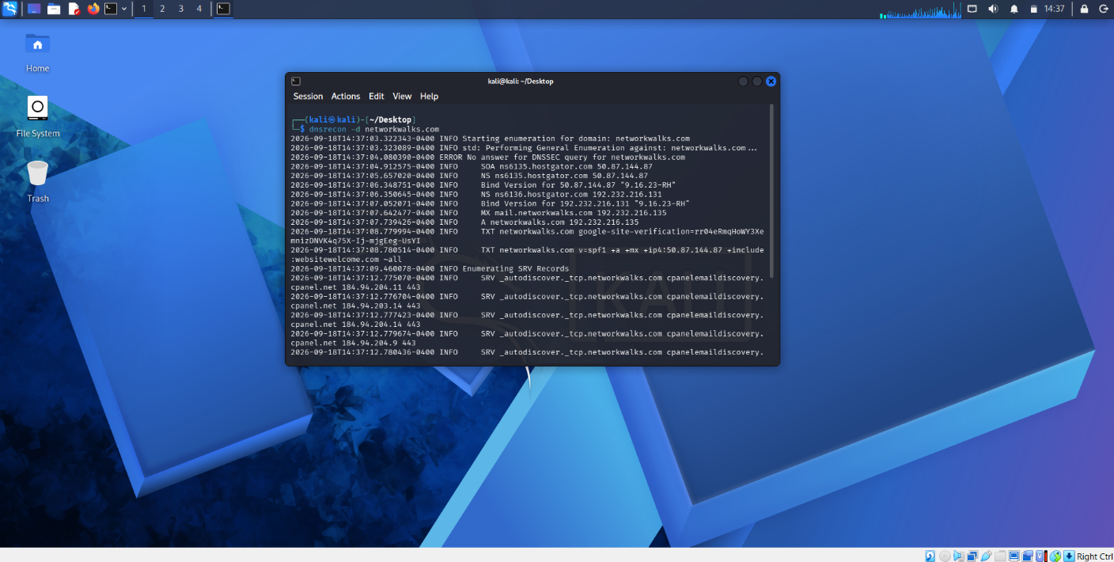

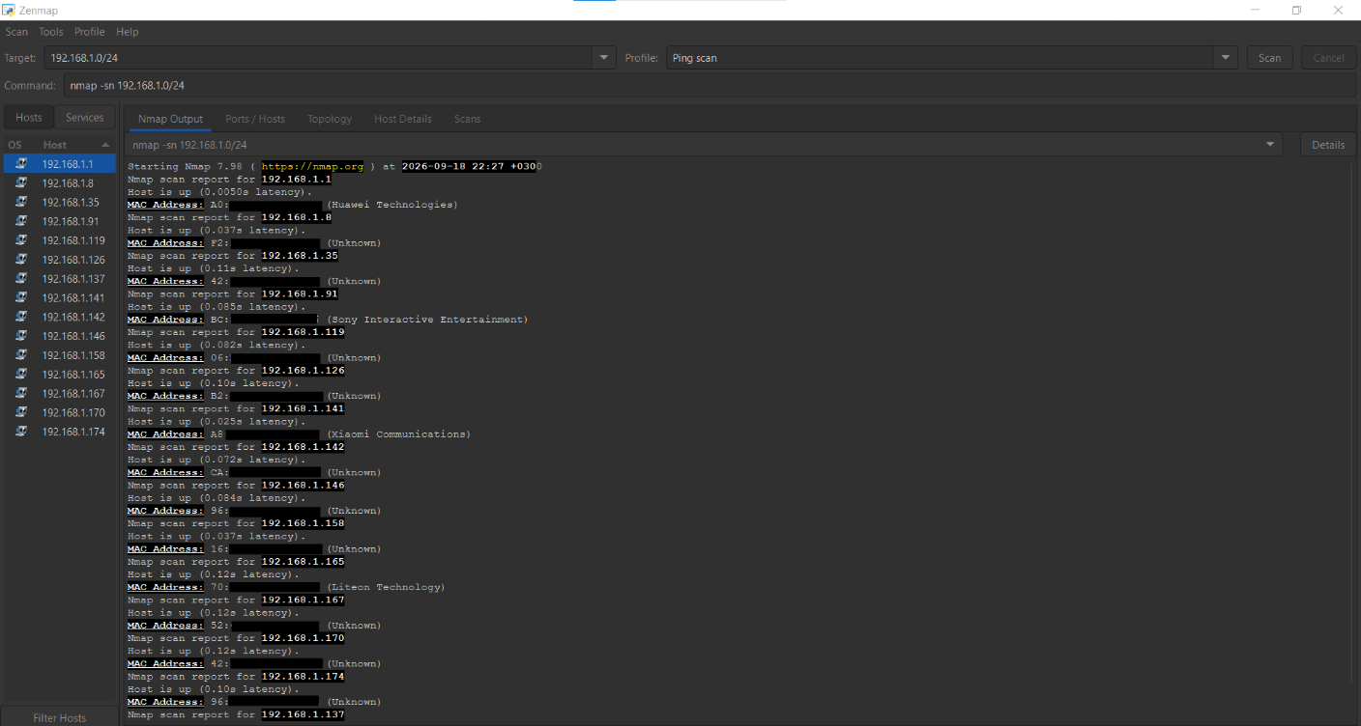

* MAC addresses have been hidden on purpose

-End-

Author
Maida Shafaq - Cybersecurity Intern, Batch B083D
GitHub: https://github.com/MaidaShafaq3/

Project Information
Program Name: Cybersecurity program at Networkwalks | Week: 02 | Repository: GitHub

